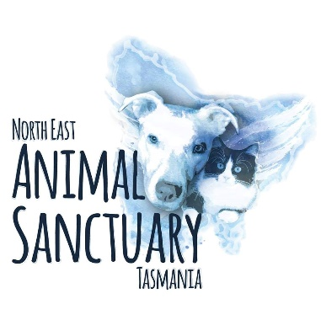
Application to Adopt

Name: ____________________________________________________________________________
Address: __________________________________________________________________________
Home Phone: ___________________________ Mobile Phone: ______________________________
Email Address: _____________________________________________________________________
Name of animal are you applying to adopt: ______________________________________________
Are you over the age of 18? YES NO Date of Birth: _______________________________
Do you have children in the home? YES NO If yes, ages: _________________________________
Is anyone in your household allergic to animals? YES NO
Do you own your home or rent? OWN HOME RENT Residential type: ____________________
If renting, do you have permission to have a pet? YES NO (Please note we will require permission in writing should your application proceed)
Are you currently working? YES NO FULLTIME PARTIME
If yes, where will the animal be when you are at work? _____________________________________
What characteristics are you looking for in a pet?
________________________________________________________________________________________________________________________________________________________________________________________________________________________________________________________________________________________________________________________________________
Will this be your first pet? YES NO If no, who is your regular vet? _________________________
Are there other animals at your residence? YES NO
If yes, please list: ____________________________________________________________________
Will the animal be allowed inside including at night? YES NO
What type of yard and fencing do you have? _____________________________________________
__________________________________________________________________________________
__________________________________________________________________________________
Have you ever been refused an adoption or purchase of an animal before? YES NO
If YES why? ____________________________________________________________________________________________________________________________________________________________________
Have you given an animal away or surrendered to a shelter before? YES NO
If YES why? ____________________________________________________________________________________________________________________________________________________________________
Do you give us permission to inspect your home and yard? YES NO
Please note yard checks are a non-negotiable requirement to adopt from NEAST.

By signing this, I confirm that all the information that I have provided is true and correct as of the _______/_______/________ . I understand that this application does not guarantee that I will adopt the animal mentioned above, and that it can be withdrawn at any time if I change my mind or if North East Animal Sanctuary Tasmania declines my application.

Signature_____________________________________ Date______________________________

Name of Applicate__________________________________________________________________

